It took me almost two weeks to unwind … but having reached Sydney on our way south from Brisbane, I feel like I have eventually arrived in Australia. Why did it take so long to unwind? Probably because things wind in reverse direction in down under. When I spotted a snail in Dorrigo National Park I noticed there was something awkward, but I couldn’t tell at first. Then I realized that the snail shell did wind clock wise. Alex joked that Bart Simpson once asked, staring into the porcelain, if the Coriolis force changes its direction on the southern hemisphere. It does indeed. Try it and flush. It might therefore have taken my mind this time even longer to adapt to local conditions and find its direction.
Urbanization Forerunner
Australia was from Noosa to Coffs Harbor defined by endless, beautiful beaches and varied wildlife. Since we have taken the Waterfall Way we drive through hundreds of kilometers cattle farmland with occasional subtropical rainforest national parks in between. I observe the small villages and the wide space even between single farm steads. It appears as if Australia consists merely out of six urban areas: Brisbane, Surfer’s Paradise, Sydney, Melbourne, Adelaide and Perth; The urbanization rate must be above 80%. And my impression is confirmed by Wikipedia: 89%. Of countries proper, which are not city states, only Japan and Brazil have a higher urban population.
Australian cities are nevertheless different from what I know from China, Japan or Europe. They are widespread and people live predominantly in detached houses. We are told by Sydney friends, that Sydney extends over a similar area as Beijing, which is divided into 24 councils and some 600 neighborhoods. But Beijing, which is roughly 16k km2 large has to fit in some 20 million people; Sydney has only 5 mio inhabitants on 12k km2 and large parts of the town feel like a park with houses tucked into the forest. Apart from such large agglomerations, one leads a pretty isolated life and can easily choose to refrain from interaction with the outside world.
It seems though that Australians do not want to be isolated. Most of them live along the coast lines, and I believe it is this peculiar geographical dimension of that continent-like island, a huge desert within and fertile only along parts of the coastal margins, which contributes to urbanization and thus to a peculiar cultural development: Australians seem due to this geographical peculiarity more vulnerable to the negative effects of capitalist consumerism.
Another reason might be the permeability of a society which is defined by being of an immigrant nature. Chinese friends from Shanghai who have moved to Sydney a few years ago, tell us while queuing up for dinner outside a Vietnamese Pho restaurant, that Sydney is very similar to Shanghai: things are absorbed fast; news spreads quickly by word of mouth propaganda; traditions and customs have no chance to establish themselves. I am tempted to assume that there is not much more than rumor mongering in Down Under considering that supermarkets like Woolworths sell only tabloids with pregnant celebrities staring at the consumer while waiting to have your purchase stuffed into an insane amount of plastic bags. Woolworths is with AUD 59 billion annual revenue Australia’s second largest business after Wesfarmers, another retailer. Like last summer in Japan, I am amazed by the might which those retail conglomerates have in our consumer societies. Whatever they shelf is what the average person will ingest.
We drive 35km across town and back for a bowl of beef noodles. Where else would one do that? Either there is scarcity of good food or people get influenced to easily in their consumer habits. Or both. If Sydney stands for the urbanized Australian society at large, then these traits speak of a society which is highly susceptible to the forces of the market and smart marketing. Documentaries like Food Inc., Supersize Me or Fed Up have clearly shown, which health havoc the profit greed and the marketing psychology of MOCs cause to consumers. I have seen little counter initiatives in Australia like pictured in the documentary Demain, which are mushrooming in Europe and pockets of the US like Oregon, Colorado and Washington State. The question crossed my mind not only once: why?

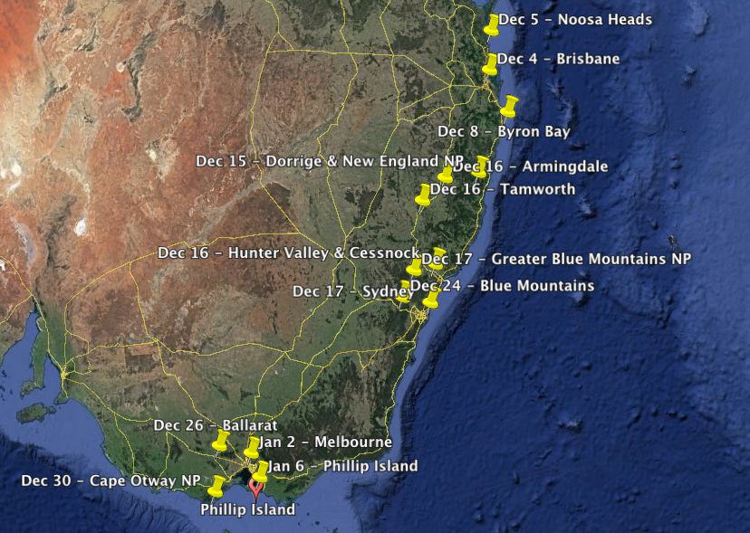
Preliminary Conclusion
After five weeks and more than 5000km traveling from Brisbane to Melbourne with some detours to off the beaten track destinations I have come to a conclusion. It might be over simplified, because I haven’t seen much of this vast country, but I have traversed the area which is home to about three quarters of the Australian population. Thus I believe that my impressions can be generalized to the society at large: Australia is a nation which thrives on the exploitation of natural and human resources to such a degree that its affluence hampers technological innovation and cultural progress. It is in its essence a shockingly backward pleasure society.
Now, I don’t want to offend anybody with this conclusion and I am far from pointing with a finger on Australians or Australian politics. Similar issues are prevalent in other societies which are close to me, in particular the German speaking countries of Europe and China proper. But I take the perspective of an independent observer who tries to understand the dynamics of cultural biospheres, someone who wishes to learn best practices and wants to avoid worst cases; and I speak as a father who looked with some expectation into Australia as a potential habitat for our two children, since I feel that our time in Shanghai and China as such is coming after more than a decade to an end.
Australia and New Zealand were two natural top destinations, since we enjoy our life in an Asian setting. Both countries seem to reflect on a societal dimension our own family microcosm, which oscillates between Europe and China. An Anglo-Saxon frame society, thoroughly changed by immigration waves from other European and Asian countries. English as first language and Mandarin as second most spoken language as shown in below map served as a good indicator that our expectations would be fulfilled. The formula was simple: take one teaspoon of good old Europe, another of good old China and a third one of a rather unknown composition and mix it with an awesome surf under blue sky and indefinite sunshine. The recipe was promising, but it didn’t go down well. What remains is a memory of a stunningly beautiful country, a peculiar and endangered flora and fauna - apart from flies, which seem to be the only species which outnumbers humans – and an admirable surfing culture. So much for the upside.
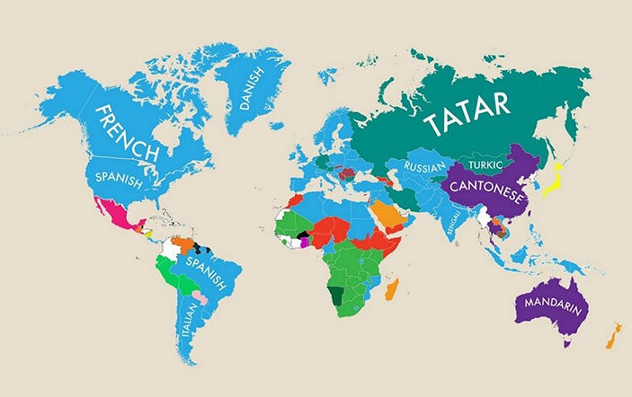
Surf Culture
Life is without doubt different from what we know. But then again probably not all too different as in particular urban cultures seem to converge globally. Lin Yutang has an undeniable point, when he writes: Culture as I understand it, is essentially a product of leisure. Austrians ski, Chinese eat and Australians surf. Like penguin colonies they lie on their boards and wait to catch the right wave as early as 7 a.m. Surfing is a mass phenomenon in Australia; and an understandable one. Life is a like one long surf.
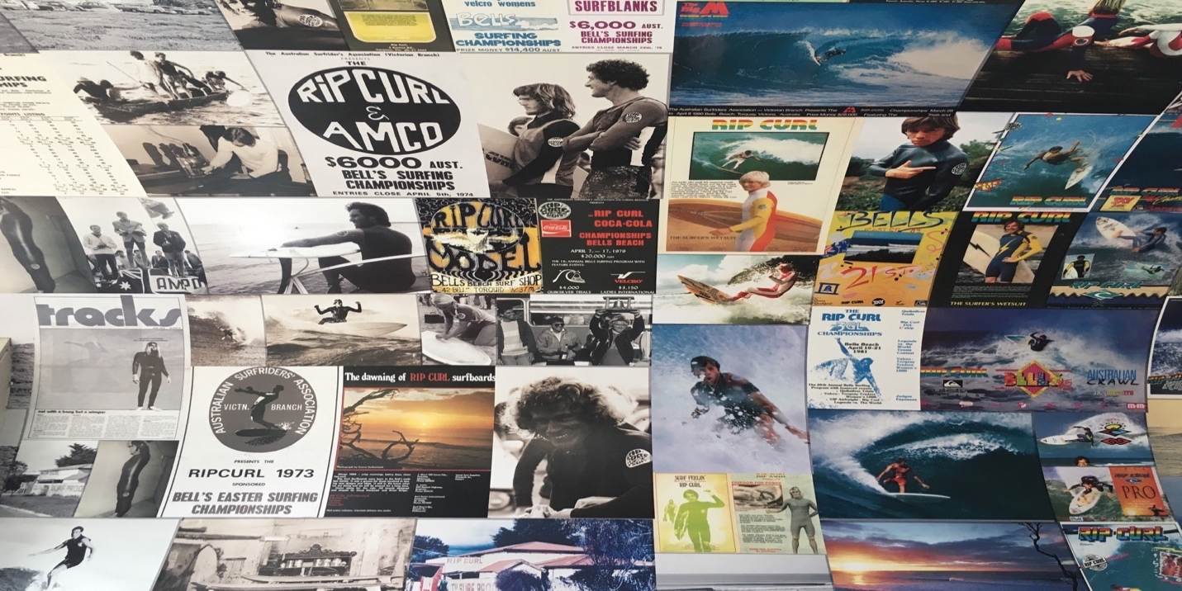
Since I have seen Point Break in 1992 the spiritual dimension of surfing has emerged in my consciousness as metaphysical reality. The similarity with snowboarding in its movement along the bodies lateral axis in a rhythmic sinus wave as opposed to most sports in binary mode along the medial axis, is probably what caught my immediate interest. But it was the combination of this movement with the peculiarity of time, which gives surfing its divine character: the surfer waits until the wave comes; gets up in the right moment and surfs it then vigorously. Surfing is the physical expression of the Taoist principle of non-action; and I believe that there is no better metaphor as surfing to make this fundamental principle of life understood to the layman.
Whereas the snowboarder is able to elicit a similar movement as the surfer, it is only the surfer who has to learn to wait. The snowboarder is entitled to an almost mechanistic underground, which makes it possible for him to reproduce his movements more or less at his command where and when he desires. The surfer on the contrary is required to wait for a wave which is large enough to carry him properly and like in archery he needs to catch the right moment, when he is fully focused to jump on. If he misses this moment all his effort to paddle offshore and time to wait are wasted.
Surfing is in other words a playful practice for the body-mind equilibrium. The passionate surfer essentially aims at a state of atonement by tuning into the tidal rhythm of the ocean. I am surprised that we have seen Zen in the Art of Archery or Zen in the Art of Motorcycle Repairing, but not Zen and the Art of Surfing. It would be such an obvious title. But probably surfers are the least likely kind to put their experience into philosophical terms and we are left with Point Break as closest to what such a manifesto could look like. Genuine surfers seem to live along the famous Zen paradigm ‘Stop thinking and talking about it and there is nothing you will not be able to know’; only their groupies, like myself, observe and try to describe insufficiently.
Those who life for surfing teach it like a religion to their children, like the father with Viking looks， whom I observed in Ballina getting his probably 5-year son on the board and onto the bay swell. Those who live for surfing also die for it and take the risks of dangerously breaking waves and lethal sea predators like 16-year old Big Pete who had gone surfing and never returned as a plaque at Ballina North wall tells.
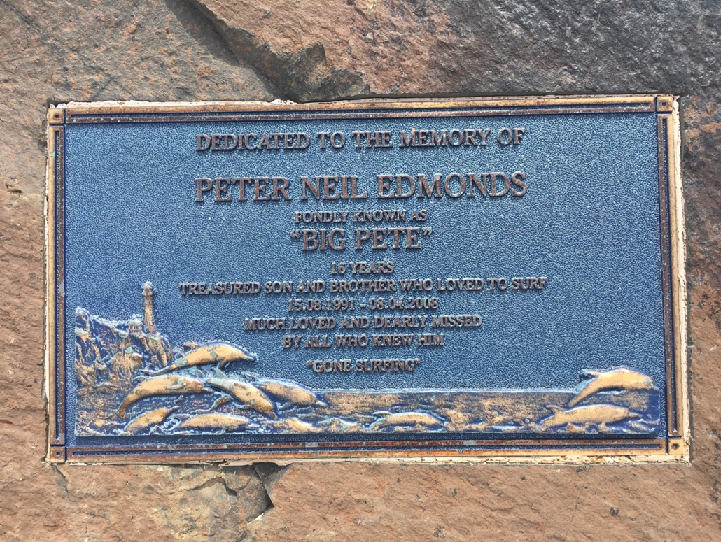
Pleasure Culture
As for the downside, there are a few aspects which deserve further elaboration. Not only because they are peculiar about Australia, but because these aspects are also social realities in other societies; and its subjects are always at risk to mindlessly go down the one or the other trap-like slide. I talk here about a way of life, which we adopt, not so much as a conscious choice, but as part of a cultural mix in which we grow up or grow into. Being a foreigner and traveler brings the advantage over the sedentary citizen of a society to be able to observe easier than it is from within. Sometimes such observations can be enlightening; often more about oneself than about others as Mark Twain once wrote: Travel is fatal to prejudice, bigotry, and narrow-mindedness, and many of our people need it sorely on these accounts. Broad, wholesome, charitable views of men and things cannot be acquired by vegetating in one little corner of the earth all one's lifetime.
Even though Australia is not at all a little corner, it was obvious that most Australians – like most people – spend their live in one relatively limited area like Sydney, Melbourne or the Sunshine Coast. The lady from Europcar Brisbane, where we picked up our vehicle asked us about our route and exclaimed with a sigh: Oh my, you will see in the next few weeks more of Australia than I have ever seen. Most Aussies though, whom I enjoyed to make acquaintance with, are those who have left the country for similar reasons I have left my home turf. They want to experience something beyond their cultural heritage; probably because they are not satisfied with what they were conditioned with.
We have seen above that Australia is an interesting place for a sociologist to observe, because it is one of the most highly urbanized and affluent nations on this planet. As for the psychologist there are other aspects of interest like a most pronounced pleasure culture which stands against an extremely high suicide rate. Martin Seligman writes in Learned Optimism that we have the choice between a pleasant, an engaged and a purposeful positive life. I doubt more and more that a pleasant life can really be positive or lead to fulfillment, but if Australians do have one dominant lifestyle, then it certainly is a pleasant one.
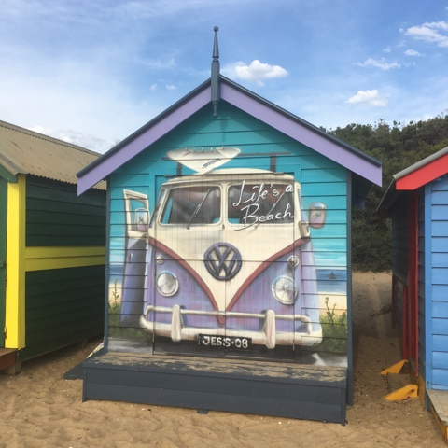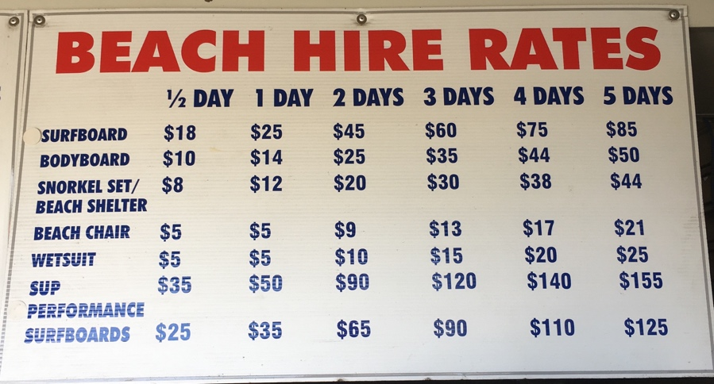
Below pictures are two scenes of such a pleasure culture. The first shows Sydney’s iconic Bondi Beach on Boxing Day. We see a young man who wears like many others on that day a Santa hat and sunglasses being captivated by his mobile screen, probably posting some beach pictures or reading the posts of his friends, who celebrate somewhere else. sic! Another common sight: An Asian woman poses for a selfie-stick shot. In the background a tightly packed stripe of sand with comparatively few people in the water.
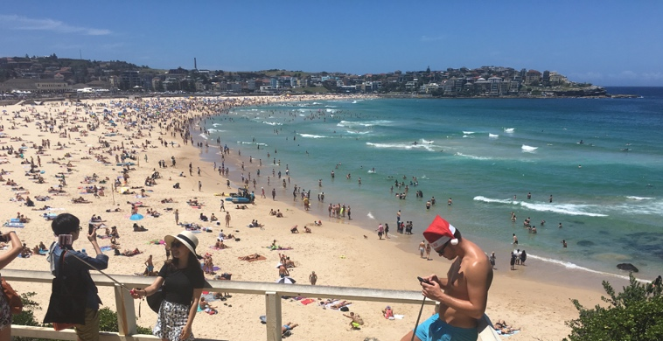

I don't quite understand the hype about Bondi and wouldn’t have bothered to go there if my wife wouldn’t have insisted to meet there her Chinese high school classmate, who has settled in Sydney with family after years in Singapore and Hong Kong. It feels like overrun Italian beaches of Rimini or Caorle in the 80ies; the number of German speakers being a good indicator. The general audience seems to be in its late 20ies looking for a mystic experience in a famous spot which has been drowned in consumerism. As such, Bondi is somewhat paradigmatic for Australia. Foreigners come here in search of the ultimate pleasure experience, but find themselves in a swamp of consumerism and tourist exploitation.

The surf is without question a point that can be brought in favor of Bondi, but man have we seen beaches up North which have at least as good a surf or better and come without the rat pack. Bondi is though a good measure of how our societies have changed. Christmas at the beach instead of in the church speaks for itself. A lifestyle of suffering has been substituted with one of pleasure seeking. I feel here a sad emptiness - because of my masochistic nature - and manage to convince our party to move south to lovely Bronte Beach, which is more family themed and has a local feel. We take there a walk further south to Clovelly Beach and have to cross old Waverly Cementery due to repair works on the cliff track. Strolling over the cemetery grounds with girls in bikinis and tanned blokes, their surfboards hooked under their armpits, coming from the other side, I am inspired about this intimate setting of death and life. Robert Bly writes in Iron John, how can we get a look at the cinders side of things when the society is determined to create a world of shopping malls and entertainment complexes in which we are made to believe that there is no death, disfigurement, illness, insanity, lethargy, or misery? Disneyland means “no ashes.” So does Bondi.

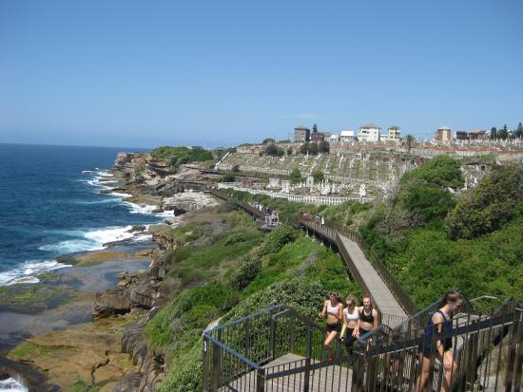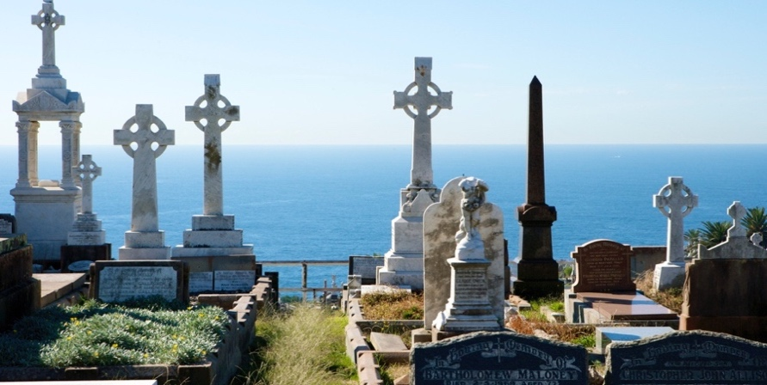

The second scene of a pleasure culture which stuck with me shows two middle aged women sitting on plastic chairs in the shallow surf of Melbourne’s Brighton Beach, just South of famous St. Kilda, sipping champagne out of large golden wine glasses. The sun is already pretty low this late afternoon lightening the colorful huts, which line the entire beach like a hand made children’s necklace.
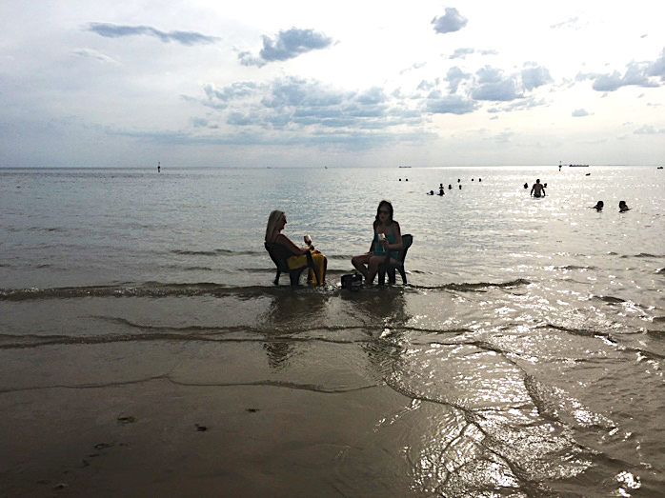
St. Kilda and Brighton are known as upper middle class neighborhoods and I have to admit that I could imagine myself living there a pleasant life. The beach and the laid back feel of the little lush streets with nice bars and cafes on almost every corner has some undeniable attraction and would probably go through as my favorite choice of dwelling should I ever consider to look again into Australia as a place to build a home. But that scene did also show me how removed and seemingly untouched Australians are from what happens all over the planet. Watching these two women felt like the incarnation of all the ignorance which I had observed the five weeks before.
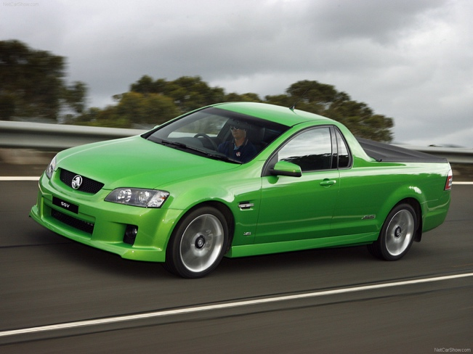
Environmental Awareness
To start with, I never really understood, why Australians have a similar carbon foot print like the Americans, because I assumed Australia to be an innovative and rather European society; but our rental car, a Toyota Kluger, which was chosen to fit 5 people and 5 weeks camping luggage compared to average Australian vehicles as rather small, in particular the three liter, six-cylinder engine. Aussies have an American fable for extra large cars or tuned sedans with monstrous 8-cylinder, five or six liter engines. Many beach and outback machos tune their cars like a bunch of competing adolescents and ear deafening exhaust pipes and roaring machines are a common pavement noise. What I found most amusing though, was the widespread use of heavy duty all wheel drive vehicles with an additional aerial exhaust pipe for high water creek crossing. Australia’s roads – at least from Brisbane to Melbourne – are in very good condition and comparable to European standard. Most Aussies probably almost never leave these paved race tracks, where a maximum speed of neck break 110 km/h is allowed. It rather seems that these big off road cars are a cultural fossil like guns in the US: they had in certain regions and at certain times, i.e. decades if not centuries ago, a genuine purpose, but are nowadays mostly obsolete. Aussies seem to hold on to their petrol guzzling AWD trucks like an adolescent to its teddy bear.
Another peculiar appearance on Australian roads are roadster pick ups with large fully closed trunks. I couldn’t help but notice that these absolutely purposeless vehicles are usually driven by the whitest Australian men - an euphemistic description, let’s be sincere about that. Since we had to cover some time on the roads I couldn’t help but wonder, why such cars are still being built and what advantage such a model has over others. I came to the conclusion, that the buyer of such a vehicle must be motivated, too, by nostalgia, because it is in its essence the modern version of early agricultural trucks, like the models we know from The Waltons, a TV series set in the years before WWII, with only a front seating row and an open pick up space behind the cabin enclosure. They were sturdy working vehicles, which saw all sorts of farming carriage. I can’t see that happen in a highly tuned Holden UTE, which is as such a grotesque mixture between racing machine and transporter. Probably the natural evolution of an overregulated society: you got to compensate in one of the least densely populated countries on this planet a maximum speed of 110 km/h somehow, right?
Mobility is always connected to energy and the first thing one observes on Australia’s roads is the almost complete lack of electric vehicles. Why, considering this nation’s high living standard? I can’t help but to draw an analogy to the UAE or Norway: rich in natural resources, general wealth is taken for granted, and the members of this affluent society have somehow lost touch with their responsibility beyond their own wellbeing and national borders. The Australian economy had China’s growth during the last 30 years fuelling its own rise by selling ores to its northern neighbor. But if all Chinese would life a resource intensive lifestyle like their southern neighbor, we would have to shut down planet Earth tomorrow. Although most roads are paved, Australians drive big and petrol guzzling vehicles, although high temperatures would call for better insulation, houses are built in American card box quality, although solar energy is abundant, only a few roofs do show PV systems.
Camping for Dr. Jekyll and Mr. Hyde

Camping grounds are probably ecologically speaking the worst form of traveling despite their huge potential to engage man in mindful living. Uncontrolled camp fires, limited waste segregation, exponentially increased waste generation, no grey water collection, waste water from campers that goes directly into custom dug ditches, gas hot water boilers instead of solar water heating, no PV generated electricity, one way cups for morning coffee provided by the camp ground owners. That what was we experienced right adjacent to beautiful Cape Otway National Park in Bimbi campground along the Great Ocean Road.

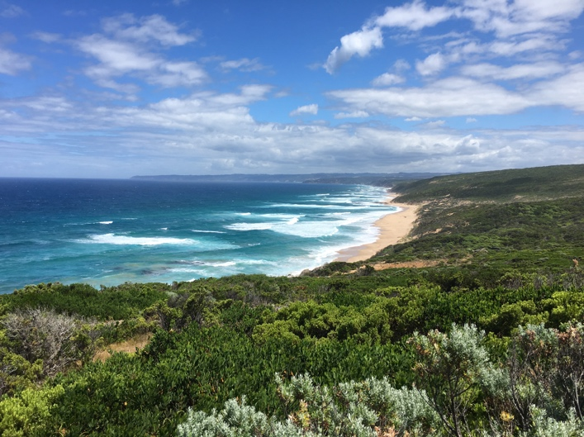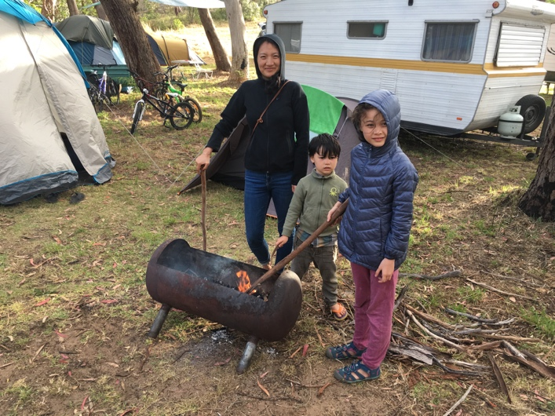

For the last two November lectures for Shanghai students, I prepared a simple slide showing the connection between space, time and attitude to generate an awareness how endogenous procrastination can be reduced. Choose a quiet space, which is different from the space where you rest. Define working and relaxing time. Set up and follow your own schedule. Do one thing only. Don’t multitask. Focus. It was difficult to explain to the students the concept of exogenous procrastination; and I understand that systemic thinking is difficult to understand if one does not have this peculiar perspective. Travelling and comparing different cultures helps a lot. By travelling through Australia, the supreme relevance of space returns to my mind.

One of the central research questions in my recent writing is concerned with the changing metrics of human physical interaction from Paleolithic over Neolithic to modern societies. My assumption is that the “comprehensive density” of physical interaction has decreased and as a result our intuitive intelligence was weakened. A certain reduction might have been beneficial to support the growth of the rational mind. But it seems that we have reached a “threshold” to speak with Australian David Christian’s Big History terminology, where a kind of counter-movement is required: physical interaction must be increased to balance rational and intuitive intelligence.

Well, the point I want to make here is that our dwellings must change - no matter whether they are in the countryside or in urban areas - to facilitate physical interaction. We spend in Australia most of our nights at different campsites in a rather Gipsy way of life; and this is not the first time that I observe how camp grounds push their inhabitants to run into each other. I don’t say that this is a perfect “facility”, but it is a starting point to analyze how people could be kindled into more interaction … I think of the village culture, which I have seen 15 years ago in Yunnan’s Xishuangbanna, with only one black-white telly, around which young and old convene after their day’s work has been done … why does everybody need a telly? a washing machine? a dish washer? A drilling machine? A camp ground is probably the best environment to learn sharing. Only Republican hunter type of people have all their outdoor gear lined up and would never bother to ask their neighbor for a spade or a lighter.

On the other hand, I have learned to detest the hippie centres of Eastern Australia like Nimbim; too much shared experience might in the end be a bad experience. Its all about the right balance between sharing and still being responsible for oneself and respecting one’s own as well as other’s space. Non profit initiatives like the Swiss share economy platform pumpipumpe or the UK version Streetbank tackle this issue by bringing the potential sharing experience of the camp ground back to your home. The limits are obvious though: we still live within our own walls and have to invest into the most expensive infrastructure which is usually located in the kitchen and the sanitary rooms. But who does really want to share those for good?

Private camp grounds are modern gold mines and seemingly there are no or very lenient government regulations on how to run them - even if they are situated in a NP area like Bimbi park in Otway NP. It seems that international NP regulations do not apply to Australia. Even small green areas in Sydney like Sydney Harbor NP are being labeled NP and areas right next to the national parks are open to business exploitation. The Australian Government would be well advised to release state of the art standards according to which camp grounds and NP ought to be run. My general feeling is that both government and private enterprise exploit Australia beyond measure. Camp grounds which do not comply with these measures should have revoked their licenses and new camp grounds must be equipped and designed according to legislation. Considering that camping is Australian’s second most favorite pastime (after surfing, no question) and foreign tourist’s preferred mode of travelling the environmental impact on thousands of camp sties could be significant.

Our experience in regard to nutrition reveals another negative effect of camping: a vast and uncontrolled diet variation due to exponentially increased grocery price levels in holiday regions and a lack of understanding of local products and brands. The elaboration of the prepared meals decreases due to lack of infrastructure and waiting to be next in line to use e.g. the gas stove. As a consequence, campers tend to flock to supermarkets and buy prepared or even ready to eat food. In other words, one of the major learning windows that camping offers, i.e. appreciating all the technology our modern households contain and learning to slow down for a few days by having to walk 300 meters to brush one’s teeth, take a dump or cook a meal, this learning windows shuts itself as the lazy camper easily yields to the temptation of eating poorly cooked meals or skipping them all together for a junk food bowl at the next drive through.

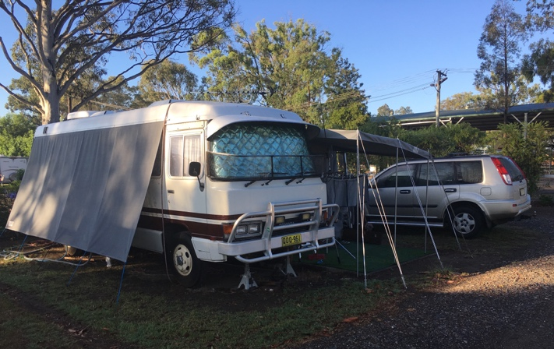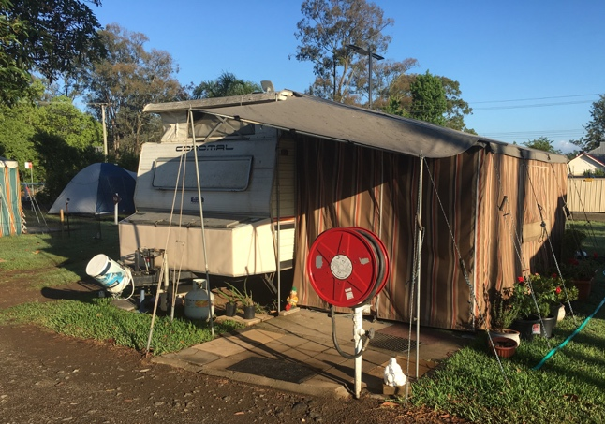
American Way of Life
Single, detached and mostly dilapidated houses on rather small plots. Permanent caravans on run down camp grounds. Overweight people in their front yards. No life without a car. Supermarket chains and petrol stations. Cessnock, a small town in Australia’s oldest wine region, Hunter Valley, about two hours north of Sydney, gave us a gloomy impression, which reminded me of Gary, a small town east of Chicago, through which we passed on our journey across the US back in 2009. You don’t want to grow up here. There is little hope, but the hope of escape.
We have dinner in a huge local pub, warmly recommended by the lady at the reception, just five minutes walk from our camp ground. Big people drink small beers and eat large chunks of beef. Mechanistic societies, which have a low consciousness about the impact of nutrition, create suffering in form of economic hardship and long term diseases. The documentary Planeat put this insight into a compact visual package. Cessnock is the living proof. Australia is after all much more Americanized than expected: mindless consumerism abundant, obesity widespread; and it is not the people’s fault, it is the culture, which drives them into such livelihoods. You really have to make a very conscious choice to carve out a different lifestyle in such an environment.
Disguised Slavery
We meet with friends from Shanghai meaningfully at Sydney’s Chinaman Beach and stroll to Balmoral Beach for the nation’s favorite: fish & chips. Aldous is an experienced architect who has moved to Sydney half a year ago and vents his frustrations about his work experience in an upscale Sydney architectural firm. He confirms my impression that Australia exploits 457 work visa immigrants, it thrives on their sweat and blood at least for the first 4 years until permanent residence status is obtained. Immigrants must take night shifts, must accept extra shifts, native Australians usually close shop between 4 and 5. There is a mentality amongst Australians that foreigners come to their great country and therefore need to earn their PR dearly. Most “first world” countries have immigration policies like this in place. Only that Australia has taken the pole position within this first world and therefore manages to scoop off the migrant cream whereas countries like Austria or Germany with poorly managed immigration laws attract mostly badly educated political or economic fugitives.
The general perception that there is little innovation in Downunder is also confirmed by Aldous. Overregulation and vested interests by old Anglo elites hamper innovation in almost any aspect. Sydney seems to be worst of all Australian cities with 24 councils who fight for their local power despite the national governments directive to merge them into 6 councils. Aldous tells me that each council has construction regulations of more than thousand pages, thus effectively limiting the architect to maneuver in between a mine field of mostly purposeless local norms. He continues to rant about building standards, which are for major developments definitely poorer than the projects he implemented over the last decade in Shanghai. Real estate developers are entirely driven by profit and little thought is given to environmental impact and technologies. Again I have to ask: why is that? The answer is in my humble opinion again the abundance of natural and human resources.
Aldous elaborates furthermore that similar regulations for the Construction and Real Estate industry - the difference in Sydney is however the sheer mind-boggling quantity, over-complexity & bureaucracy which comes included. Ironically these regulations were initially drafted and put into law to improve the often poor building quality. For many years large local developers like Meriton could get away with substandard buildings (particularly apartments) in order to maximize their profits..
These very same developers follow the new guidelines with the very same attitude now - it means that eventually you end up having similar, "optimized" yet compliant typologies, residential units etc. over and over again. And of course, they're usually not willing to pay anything extra beyond the minimum requirements. Since demand still greatly outstrips supply (thanks to mostly Chinese buyers in recent years..) for residential buildings and apartments, most of these are being sold based on their "location value" only. Thus, large Chinese Investors/ developers which have been flocking into the market in recent years as well, were building their developments with higher quality & standards and certainly also more luxurious in order to cater the needs and desires of their wealthy Chinese clients and buyers.

Paul, an accomplished project engineer, who spent 10 years in Europe and recently moved back to Sydney, tells us that he currently applies for a NSW government position. He speaks several lingos and has many years work experience in interior renovation for luxury hotels abroad, what should give him a pole position. He says that candidates are selected by the government on merit only. I can't believe that after what I have seen so far. Australia is organized like any other society in the words of Max Weber somewhere around law and relationship. I have the feeling that 200-year-old laws tend to favor relationships; in particular, amongst white Anglos, who naturally try distribute well paid government jobs amongst themselves.

I recall once more that tax law was probably the most useful subject I had in law school, because it teaches about the mightiest stream of cash in our societies; and it is probably the most efficient tool to change society for the better. I wonder about Sydney's detailed tax regime and the taxation keys, which taxes are levied on residents, on real estate owners, on consumers, on businesses; how much stays with the councils, because some Sydney districts like Mosman or Vaucluse are blessed with extreme wealth, whereas other areas like Hunter Valley's Cessnock struggle with dear poverty.
Outback Innovation
The exploitation of working visa immigrants and the wealth in natural resources might also be the most obvious way to explain the lack of innovation. Is there a single Australian product that comes to your mind? Not to mine. Oh, no, I forgot OGG sheepskin boots. An obvious product for the Australian climate, produced by a Californian company in China. I had though the expectation to find a highly innovative society. That’s at least the aura which metropolitan areas like Sydney or Melbourne have. Again my expectations were disappointed by reality’s delivery: a barren innovation landscape, as barren as the vast red Australian center.
But either my superficial observations take a completely different vantage point or the global innovation index looks at innovation criteria which are simply not relevant. Australia ranks 19 out of 128 evaluated countries in 2016 and quite absurdly 6 in terms of infrastructure, which is in the understanding of the report, ICTs, general infrastructure and ecological sustainability. No way, honestly, no way, this can be true. It is even in this report visible though that the high comprehensive score is at least partly attributed to, well, it depends how you want to put it, the exploitation of foreign human resources or euphemistically, smart immigration policies. Australia scores e.g. exponentially high in scientific and technical publications (rank 9) and number of researchers (rank 12) … probably not because there are many Australian researchers who write excellent papers, but immigrants who slave for some national institutes for a life on the beach. The creative output score (rank 18) is generally low when looking at single categories, but somehow the report seems to weigh the sub categories online creativity (rank 9) and global entertainment and media market (rank 8) more important than others. Good for a country which thrives on a pleasure culture.
The first thing the traveler notices, are poor internet connections, because restaurant and café staff or camp ground employees repeatedly excuse network failures. Mobile phone services are a sophisticated patchwork, with the exception of the main urban areas and the coast. Australians who have travelled abroad try to explain, but in the end only sigh about the backwardness of their country. So much for ICT infrastructure. I came to the conclusion that Chinese internet is despite censorship and the hassle of having to use a VPN service the better experience.
Far more important than communication seems to be transportation, in particular in a country as vast as Australia, which has the disadvantage of its size to make public infrastructure investments pay off within short time. But again it must be said that at least between the two major cities of Melbourne and Sydney with the national capital Canberra in between a medium-high speed railway line should be a question of national pride, if not of general purpose to make the journey for more than 10 million people on a distance of about 900 km more convenient and with less environmental impact. At least the volunteer staffed driver reviver outpost wouldn’t be needed anymore.
But like Americans, Australians are people who prefer to either drive or fly. I envy them for the freedom to be able to even fly without license on private airplanes in restricted areas. A friend who grew up in Victoria’s Yarra Valley and now lives in Guangzhou, told me that he would fly with a 4 seats Chessna on day trips. Great perks for the pleasant life. What struck me though is the state of commercial air traffic. If major transportation hubs reflect the organizational state of a society and Sydney airport would be taken as a measure, then Australia is either a general mess or we just happened to be there on the wrong day. We waited for about two hours at the arrival exit gates for my delayed wife and children to arrive from Shanghai. The Christmas holidays definitely increased the number of travelers, but it was interesting that no airport staff was in place to guide the masses smoothly from the arrival gates to the exit proper. People flooded in and the relatively small arrival hall got extremely congested. In such a situation a siren-like alarm went off inducing not only in me the daunting feeling that something was utterly wrong. People looked at each other with asking gazes, but even after minutes no information was provided by the airport authority. Instead flight announcement in a far too low volume to be possibly understood continued. We were relieved when we left Sydney airport for good. You don’t want to be in that building if something really goes wrong. Brisbane airport was quite on the contrary a very pleasant experience, but seems to be, measured in size and passenger turnover, a real back water destination.
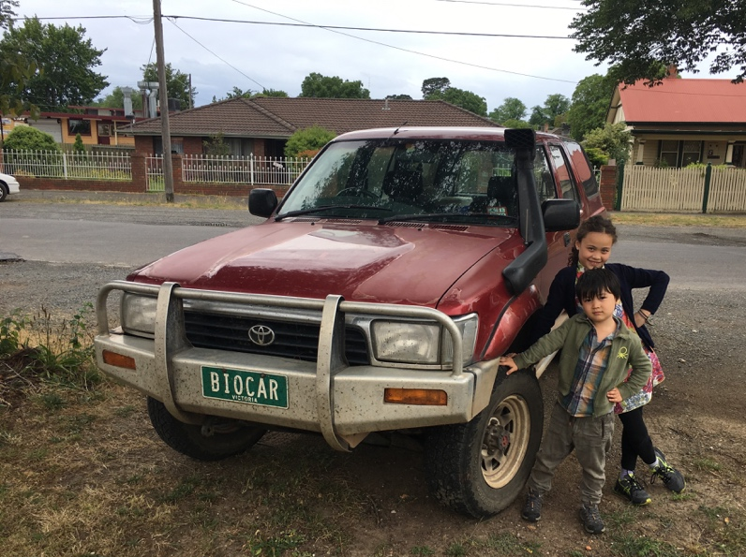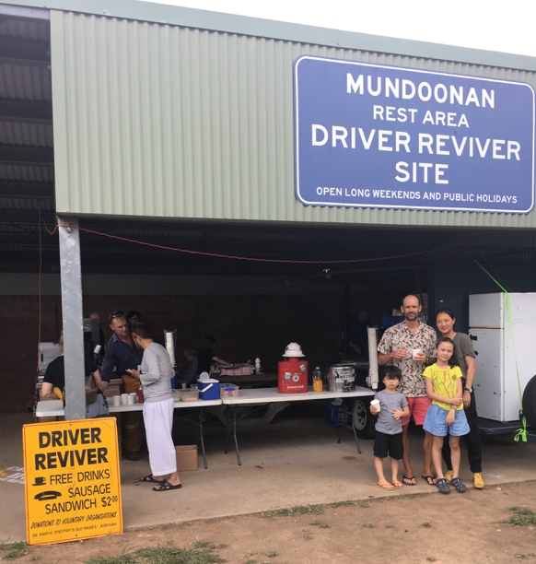
If one does not want to rely on public transport, the road system is generally in great condition. But we have noticed that Australian roads in all urban areas are highly dangerous and extremely disturbing. Only few urban motorways are fully separated from the residential areas, most are cut right through them. Although speed limits are set at 70 km/h on urban motorways, they are built without noise barriers. The result is that houses even in upscale neighborhoods which are situated next to such a motorway loose not only in value, but are not suitable for families with small children. Imagine that a six lane motorway passes right in front of your garden and that whenever you pull out from your garage you are directly on the motorway. I felt that driving on these roads demanded exponentially increased attention for people pulling either in or off. But what about children playing next to those roads? You would never be able to break in time. In my experience, most European motorways in urban areas are sealed off from residential neighborhoods, either by noise barriers or by being underground. I can’t remember to have seen a single underground motorway in Sydney apart form the tunnels passing through the harbor between North and South Sydney.
Considering living standards and convenience, yet another aspect came to my attention. Biking is hardly possible and mostly extremely dangerous. Melbourne has done more in this regard than Sydney with a considerable amount of bike lanes, but still there are not too many bikers being seen in the streets. The reason is in my opinion again, how roads are built. Whereas I am used to have the pavement on the very inside, the bike lane next to it, then parking cars, and last the driving lanes, Australian bike lanes both in Sydney and Melbourne are between the driving lanes and the parking cars. This means that the cyclist is effectively threatened twice: by cars speeding next to him at tempo 70 and drivers who have parked their car and open the doors without paying attention.
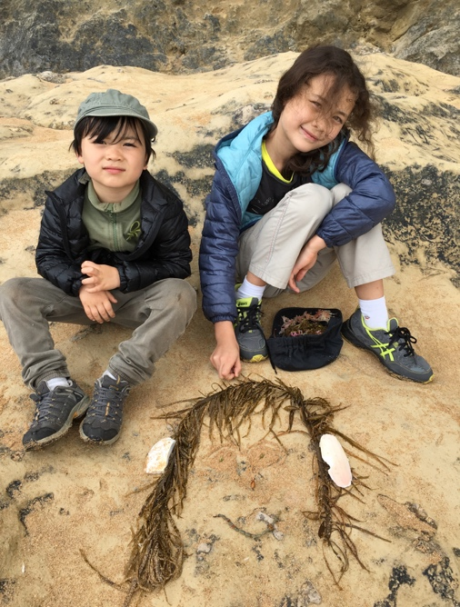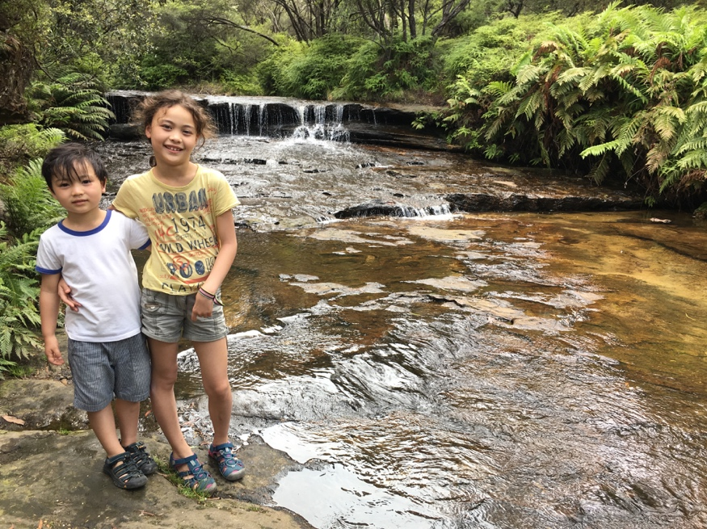
Now, I understand that one or two Australian readers will think that I have nothing good to say about their country because I had five weeks of menstruation caused migraine. That was probably a sexist interjection, I realize, but as I expressed earlier, my focus of observation was in the first place on Australia as a place to live for a few years as a young family. I did not so much bother about Australia as a tourist destination, which has – no need to argue about that – a lot to offer to the outdoor and wildlife enthusiast. I have to say though that the three weeks we travelled in Japan last summer have left a much better impression on me and without the slightest interest in moving to Nippon, I felt so deeply touched by its natural beauty and its culture, that I wouldn’t hesitate a second to move there for a few years. There is much to learn in Japan. Innovation is a ubiquitous element in society, and new gadgets and technologies can be spotted almost everywhere. Australians and their cultural mainstream appear to be comparatively backward and literally heavily built.
In terms of innovation what is left to ask is why such a highly urbanized and wealthy nation is not more creative. If we believe the author Steven Johnson who analyzed in Where Good Ideas Come From most thoroughly the aspects of creative spaces, then Australia would have drawn the jackpot. It is though Niall Fergusson who reveals why Australia is not innovative. He argued in Civilization – The West and the Rest, that six novel complexes of institutions and associated ideas and behaviors distinguished the West from the rest and were causal for the Eurasian world dominance for the last 500 years. These killer applications are competition, science, property rights, medicine, consumer society and work ethic. Australia misses above all one ingredient of this mix: the work ethic. It is not only once that I have heard from both immigrants and natives, that Australians are lazy. Abundance in natural and willing foreign human resources are responsible therefore.
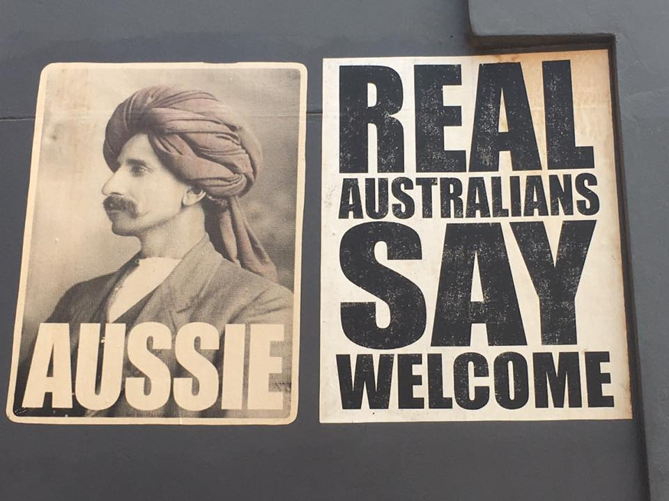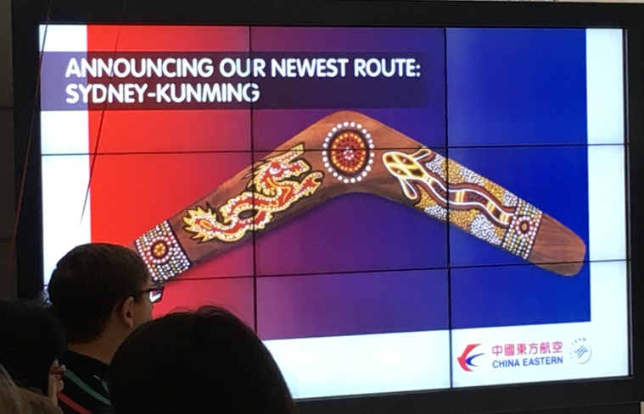
Immigration Then and Now
Australia’s history is a history of migration and immigration, in particular during the last 250 years. It is true that the aboriginal population must have also immigrated to Australia some 45-60.000 years ago, but Australia was then terra nullius, uninhabited land, and could therefore be considered to be migration, not immigration. The Australian historian Manning Clark writes that the expansion of all three, Hindu, Chinese and Muslim, petered out just as they came to that invisible line on the map between Timor and the Moluccas, where civilization ended and barbarism began. So chance probably prevented the coming of civilization to Australia two or three centuries before the arrival of the European. It was the Dutch who eventually made sight of this vast island in the sixteenth century when exploring further South from their East India Company trading posts on what is now Indonesia. Probably the first description by a European of Australia was delivered in 1606 by Captain Willem Jansz, who is told to have said: There was no good to be done there! It could well be the title of this essay, albeit from a different perspective.

It was only about 150 years later that the English set foot on the continent and stayed. Captain James Cook landed in 1770 at Botany Bay near Sydney and took possession of Australia for the British Crown as New South Wales. Since Britain had lost through the revolt of 1776 its preferred channel of disposing criminals to its American colonies, Sir Joseph Banks recommended in 1779 to deploy British convicts to the new Pacific territories as settlers. The first batch of 750 convicts arrived at Botany Bay on January 20, 1788. 168.000 would follow until 1868, when the last convict transport from England arrived in Australia to end this second chapter of immigration to the continent.

Australia's population has grown from an estimated population of between 300,000 and 1,000,000 at the time of British settlement in 1788 due to numerous waves of immigration during the period since and is estimated to reach 28 million by 2030. The most peculiar wave of immigration is the one of Chinese gold miners in the 19th century, because it is the history of the gold rush 170 years ago which reminded me in so many ways of the current situation. Manning Clark writes that the Australian gold rush was initiated in 1851 by E. H. Hargraves who returned to Sydney from the Californian gold fields with the strong conviction that the geological conditions of New South Wales and Victoria resemble the Californian ones. He proved to be right and once the word had spread around the globe the third immigration wave to Australia had started.

Chinese immigration to Australia is recorded since 1818, but only during the gold rush and in recent years the numbers were really significant. We had the opportunity to see some historical documents about these two periods at Sovereign Hills, an old gold mine near Ballarat, which has been converted into an open air museum / entertainment park, and in the Museum of Chinese Australians in Melbourne. Both locations reveal a history of racial segregation and competition and again, I have the impression that there are a few analogies between then and now. In terms of statistics both then and now the European component of the population is declining as a percentage. Both then and now a Western value system is challenged by an Eastern. Both then and now new modes of business operation compete with established ones.

Manning Clark writes that Chinese began to arrive in the gold fields of Victoria in large numbers during the years 1855-56, when the income of the alluvial diggers was sinking to that of unskilled manual workers, and when gold was being found at such depths that gold-mining by companies, employing diggers as wage earners, was beginning to replace alluvial digging by teams of four to six independent diggers. One has to understand that the Australian labor market was exposed to unusual fluctuations during the gold rush years. When the first news of gold findings was broken, entire towns were left deserted, because everybody wanted to have a piece of that new wealth. By 1852 the gold rush had subsided, because many first time diggers had realized that they were not made for the hardship of such life.

Clark continues: The Chinese though came from Southern China, generally bound to some headman to work under his orders to pay depts. In the homeland. They arrived in groups of six or seven hundred, each man with a pole and two baskets and a hat like the top of a haystack nearly a yard across. One can immediately see that two different organization structure collided on the fields. Alluvial Western diggers who were organized in teams of 4 to 6 were outnumbered and Western companies were probably not able to exploit their employees to such a degree as Chinese headman. In both cases an increase in competition was felt and by 1857 Europeans had become afraid. Roughly 200.000 European diggers, 73.000 of them women, registered on the gold fields of Victoria, started to accuse 24.000 Chinese diggers, all of them men, of committing crimes and not contributing to the country by exporting all their wealth to China. The principal not outspoken grievance was though less yield of gold and a decrease in the price of labor.

When reading Clarks account of the gold rush period and visiting Sovereign Hills I was reminded of two 2016 articles. One was about Australian tycoon and politican Clive Palmer, who called Chinese mongrels and elaborated on his choice of words: They're "bastards," he said. "I'm saying that because they're Communist, because they shoot their own people, they haven't got a justice system and they want to take over this country." The other is about the Australian government rejecting a large land sale deal, in which a Chinese led consortium tried to acquire 1% of the Australian territory, i.e. a piece of the country which is roughly the size of Austria or the Netherlands and Belgium combined.

The latest data shows that between 8 and 12% of the Australian population is Asian and about 4% of Chinese ancestry, equaling about 1 million individuals. Their exposure is extraordinary high though. Sydney fish market is probably a good place to start, because it appears to be entirely Chinese territory, since both customers and staff are predominantly Chinese; Chinese tourist who visit the fish market for a cheap seafood and Chinese Australians who work there permanently. One feels as a matter of fact as being in China, only the Greek and Italian names of the fish shops tell another story. Big mainlanders gorging on spider crabs and lobster; an Australian couple who can't make themselves understood to only Chinese speaking staff; my wife paying our lunch with alipay.
At Sydney airport we witness another clear indicator of how important the Chinese have become to Australia. While waiting for my family at the exit gates, a large commercial screen shows almost entirely advertisements directed at Chinese customers. China Eastern flying directly from Shanghai and Kunming to Sydney, China Merchant Bank promoting its services in Chinese language only, Union Pay competing in one of Visa and Mastercard’s home markets. We are told though that the “white discomfort” is predominantly felt in the countryside, where real estate prices do not rise like in the cities, and people feel that they do not partake in the concrete gold rush, quite on the contrary they are squeezed and marginalized between established and new wealth.
An Australian friend who lives in England sent me recently an abstract of Australian National University international relations professor Hugh White’s recent book The China Choice. He argues that Australia’s future depends on how China and the US master their bilateral relationship. But Australian politicians and ordinary Australian citizens are ill advised to wait for what is to come from abroad. If the 1901 white policies have really been abandoned after WWII, then Australia must try to live according to its multiculturalism and make Chinese an integral part of their society. Like wise it must put laws in place that avoid the exploitation of the country as it was criticized during the gold rush. Those who have come to stay should contribute like all others. Australia must question the loyalty of its subjects. It must not ask itself whether is turns towards the US because of its predominantly Western heritage, nor towards the wealth of its largest trading partner. Australia’s future is not a question of black or white, but a question of how it creates its own color most suitable to its history and geography.
Some vested interests have to go over board, if such a process is supposed to get anywhere. Strolling along Sydney beaches gave me the impression that white Australians enjoy life in posh neighborhoods, often with sea view, caravan and boat, oblivious to the fact that either diligent and pressured or extremely wealthy immigrants take over their turf. Their loyalty is to themselves and their pleasant lifestyle. Only those Australians who have to endure the hardships of agricultural business or those who have lost their jobs in a changing labor market do bother. The country is in chaos … as an Australian friend puts it. But the interests of the European population are diverging. Those who are in power, make huge profits on tourism and immigration, whether by selling land, taxing businesses or awarding university degrees, those who are not, have to tolerate a quite rapid change in their society they are ill prepared for. Making Chinese the first foreign compulsory language in school would be a first step to prepare Australians for the things to come.

During our Boxing Day picnic at Bondi we entered a discussion with my wife’s high school mate and his wife about which places seem to be best nowadays for a young family to live. We concluded for various reasons, that Japan would be the best choice for a family with Asian looks and Germany for one with Caucasian. Australia didn’t make it into the final round for us, its heterogeneous and racially segregated structure being a factor that put us - interestingly - off.
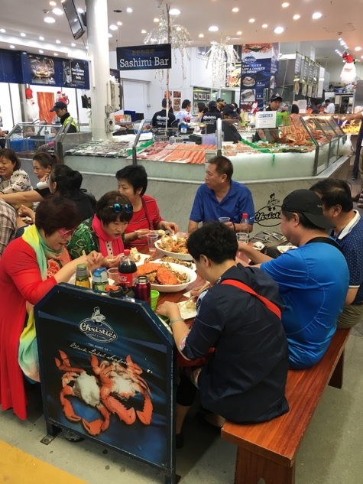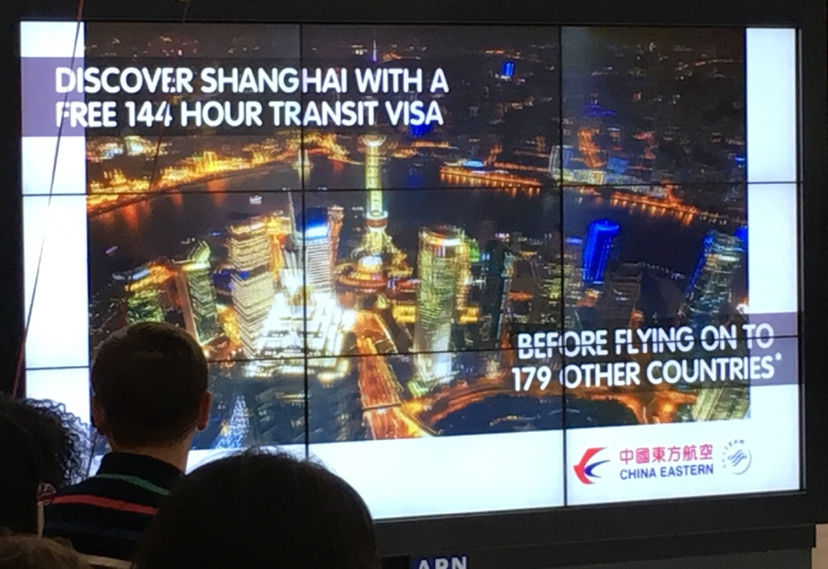
Costs of Living
Living expenses are for most people who consider to live in a country the most important criteria after having cleared legal obstacles. Five weeks are probably not enough to get a substantial insight into Australian living expenses, but I have tried to get a comprehensive overview by talking to different people and comparing available information during our journey and on open source platforms like numbeo. In short: live is outrageously expensive; roughly twice as expensive as Germany and comparable to Switzerland. A low purchasing power is aggravating this situation.

Now, I have to mention upfront that the Australian median income is about AUD 1500 per week according to the Australian Bureau of Statistics (which operates one of the most chaotic websites I have ever seen, a mere pile of stinking reports which are unloaded at this online dump to put the inquirer off by exhausting him in a search for the literal needle in a haystack) what equals roughly EUR 4200 monthly. Australians earn therefore about twice as much as Germans, Austrians, Dutch and Belgians or slightly less then the Swiss. In per capita purchasing power parity Australia ranks though almost ex equo with Sweden, Germany and Austria at roughly int. USD 48000.

The question is then rather, what one has to pay for single services, if they are accessible and which quality is provided. Tuition is a good starting point for families and in some countries the second largest chunk of living expenses after real estate or accommodation rent respectively. All families, whom we met, complained about the limited availability of day care centers and the prohibitive pricing. Kindergarten tuition ranges somewhere between AUD 100-150 per day, absorbing almost the entire monthly income of an adult. We were told by friends that the available government subsidy is roughly AUD 30 per day or a maximum of AUD 7500 annually according to online government information. Women complained that Australian child care leaves much pressure on single mothers and is comparatively backward to Central or Northern European systems.

Cheng Wen, who studied biotechnology with my wife in Vienna, but moved to Sydney with her Australian boyfriend Paul a year earlier, told us that they pay AUD 680 per week for a 2 room apartment in Rhodes, a suburban district popular with Chinese. EUR 1600 a month for a small apartment makes Sydney a pricey place to live, even more so if one has to house an entire family. We swaped our Shanghai downtown apartment for 10 days with a family in Sydney’s suburban Pymble district. AUD 1 million is the bottom bar for a 3 or 4 bedroom home in that area. Prices for properties, which are located close to the sea or even have sea view, go literally through the roof. Relatively affordable housing is only available off the cost or even better: West of the Dividing Range.

Grocery price levels are about twice as high as Germany's. We had a pretty precise indicator by shopping now and then in German owned Aldi, which made it in only a few years to the third largest Australian retailer. Fresh veggies and fruit is outrageously expensive; e.g. a kg if tomatoes would go for AUD 4 - 8 despite a climate that grows everything locally; nothing needs to be imported. Pricing is generally explained by AUD 21 minimum wages ... but isn't in particular agriculture highly automated? Fruit picking is not, we are told, and local farmers rely on working-holiday visa backpackers to do the job. A recent debate to tax working-holiday visa holders infuriated farmers, who would loose their swift foreign hands.

Beef is on the contrary extremely cheap, and I am not sure if its because beef is cheap or because Australians like to eat outdoors, but BBQs are Australians 3rd most favorite pastime after surfing and camping. Considering that cattle farming has a highly intensive CO2 footprint and consumes ludicrous amounts of water, this situation alone shows how ecologically unconscious the nation is. At least between Brisbane and Melbourne it appears that Australian farmland is used to 90% for cattle farming. It would be possibly perceived as slaughtering the nations holy cow (I like that one), but somebody should propose to levy a carbon tax on beef. Biophysicist Gidon Eshel showed the disastrous impact of cattle farming and a beef diet convincingly in several documentaries like Planeat or Before the Flood. The message is clear: the easiest thing each one of us can do to reduce the emission of green house gases is to eat less meat, in particular beef.

The meat loaded and fish & chips enriched Australian diet is most likely one main reason, why Australian health expenditure per capita has overtaken during the last 20 years according to WHO almost every single country apart from the US, Norway and Switzerland. I nevertheless believe that Aussies enjoy the best medical care of all Anglo-Saxon nations, and I have heard US citizens twice considering to move to Australia for this reason. We had only one encounter with the medical system, because both our kids contracted on the plane a persistent cold which turned into a nasty infection. I got for them an easy appointment in a Sydney medical center by using a convenient online booking system and we had a very pleasant encounter with seasoned Dr. Peter Ward. We were charged AUD 70 for each consultation, which is comparatively speaking super cheap. I was quite irritated though to learn that 457 visa holders are barred from the access to the medical system. Picking up our kids’ medication I learned from the pharmacist that Australian medicare covers prescribed medication exceeding AUD 37; the patient’s self contribution is therefore significantly higher than e.g. in Austria. I was moreover told that quite a number of drugs are exempted from medicare.

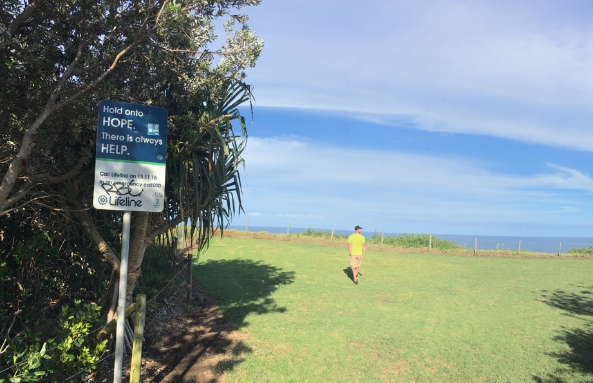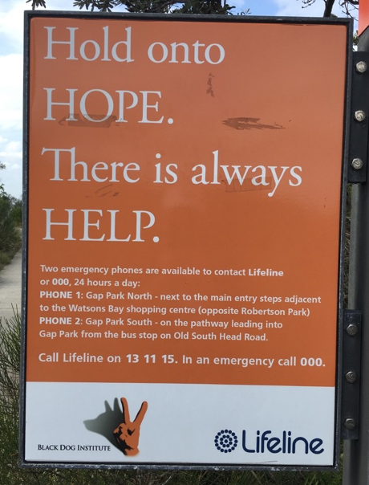
Darkness under the Sun
I knew from a recent research project that suicide rates are pretty high in Australia. It was nevertheless a kind of strange sight to read at the most beautiful cliffs lifeline boards which try to avoid suicide in the very last moment. Cliff diving seems to be another favorite Australian pastime. Martin E. Seligman, by some called the modern father of positive psychology, wrote in his 1990 publication Learned Optimism that most of the developed world experiences an unprecedented epidemic of depression – particularly among young people. Why is that in a nation that has more money, more power, more records, more books, and more education, that depression should be so much more prevalent than it was when the nation was less prosperous and less powerful?
We learn that Australia's highest suicide rate is amongst young Australian men from the countryside. They have lots of life skills from growing up on farms but seem to have problems to adapt to society. Considering the dominant pleasure culture which puts in particular in Australian cities self esteem at the center of being, I am not surprised. Seligman believes that the self esteem movement is the main reason for increasing suicide rates. Young people are being conditioned by their media flooded environment that they must feel good, have high self-esteem and exude confidence. Like my own experience with Australia, so it is with life in general: satisfaction and eventually happiness is a question of measuring one’s expectations with reality. Fly low and you can’t fall deep.
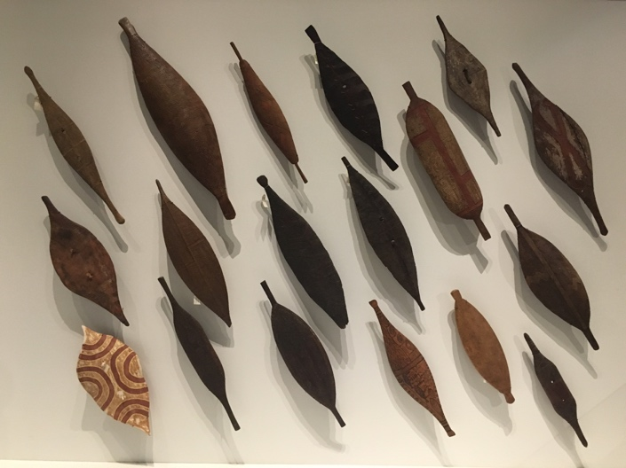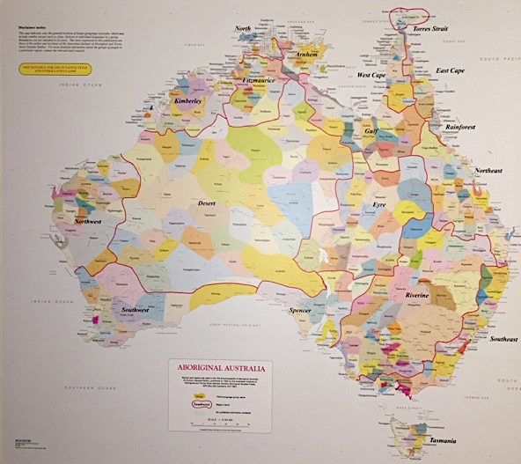
Aborigines
There are two reasons why I want to return to Australia once more: one is the Great Barrier Reef the other is to learn more about Australia’s indigenous population. It is the people who started Australian history with whom I want to end this essay, because I believe that their story and situation can teach us much about what it means to be human.

Apart from a bunch of performing aborigines in Sydney, we did not have a first hand interaction with them, well, unless Tim’s vague guess is right, that his wife has indigenous ancestry. He was partly joking that evening, but we had a pretty interesting evening chat with Tim Jones, a vocational teacher, and his wife, an accountant. They and their lovely three daughters happened to camp next to us on the Noosa Heads North Shore caravan park. Tim told us, that his family had lived for a year in Alice Springs, where Tim taught at a missionary school for two years. He described the spectacular physical abilities of indigenous kids, in particular their athleticism and dexterity. One child could predict rainfall, another could do amazing back flips, a third would throw balls precisely like a pro golfer to hit objects in a far distance at pure will. Such accounts indicate that these people have a strong physical and intuitive intelligence, but are marginalized by a dominant rational society. Tim described the consequence of this marginalization as learned helplessness. His students would e.g. not understand or fail to try to get from a situation A to target B e.g. working and saving money in order to buy a desired car. Youngsters usually give up to study during adolescence and accept their fate of unemployment and alcoholism. He believed that aborigines won’t be around anymore in a few decades from now, because their living conditions are so dire.

Recent statistics tell us, that Australia is still home to more than half a million indigenous people. This number includes though aborigines who have completely assimilated themselves to the Western lifestyle which was brought by the colonialists in the 18th century and developed quite parallel to the industrial revolution in Europe and North America. The number of aborigines who still live very close to their ancestral customs and traditions must be very small; indeed, so small that Tim was probably right.

The map above shows the incredible plurality of aboriginal tribes before the arrival of the Europeans. The Australian Museum in Sydney tells its visitors on this map that there were almost 400 distinct languages spoken by about 250 nation tribes. It is estimated that in the 18th century between 500 and 750 thousand aborigines, organized in clans of 4 to 40 people and with an intimate bond to their patch of land, lived on the continent.

Sydneyer Stephen Zissermann, whom I know from a 2013 holiday in lovely Yangshuo, told us during our stroll across the Sydney Royal Botanical Gardens that aboriginals where classified until the 1960s as part of the native flora and fauna. It was then interesting to learn details about native Australians in a museum of natural history focus. And I was a kind of shocked to read on the above mentioned map in red letters NOT SUITABLE IN NATIVE TITLE AND OTHER LAND CLAIMS. It seems as if modern Australia, despite Kevin Rudd’s 2008 general apology for the havoc which white settlers have brought upon aborigines, still hasn’t come to terms with its past, in fact not even with the very basic matters of indemnification. His predecessor Keating made it in 1992 even clearer: “We did the dispossessing. We took the traditional lands and smashed the traditional way of life. We brought the diseases. The alcohol. We committed the murders. We took the children from their mothers. We practised discrimination and exclusion.”

My recent research interest in though devoted to a very different subject: the pursuit of happiness and the impact of cultures thereon. Positive psychology did a great job in recent years to make us believe that we can turn even from a dark pessimist into an exuberant enthusiast. I did see a truth in these findings, but was left with a feeling of disbelief. The cynic within me could not accept that we just have to put on pink mental glasses to see rainbows on the horizon; and the realist saw that an individual’s mindset can’t alter an entire society’s mentality. The gut tells me that the truth must be somewhere in between.

Yuval N. Harari’s Sapiens – A Brief History of Mankind came as pleasant contribution to my research, because it is as a matter of fact not a brief history of mankind, but as he puts it somewhere himself, a history of happiness. Harari manages to write a readable oeuvre in the style of Jared Diamond, cutting as historian through many different subjects like geography, anthropology and economics, and put just a few months before we embarked on our journey to Australia a story into my head about an aborigine woman named Truganini, who died reportedly in 1876 as the last native Tasmanian. Harari writes:

Having survived for 10,000 years in splendid isolation, they were completely wiped out, to the last man, woman and child, within a century of Cook’s arrival. European settlers first drove them off the richest parts of the island, and then, coveting even the remaining wilderness, hunted them down and killed them systematically. The few survivors were hounded into an evangelical concentration camp, where well-meaning but not particularly open-minded missionaries tried to indoctrinate them in the ways of the modern world. The Tasmanians were instructed in reading and writing, Christianity and various ‘productive skills’ such as sewing clothes and farming. But they refused to learn. They became ever more melancholic, stopped having children, lost all interest in life, and finally chose the only escape route from the modern world of science and progress – death.

I did then some follow up online research to validate this account and could not find any contradictions. Harari’s account seemed to be true; Native Tasmanians were decimated by European colonists either by force or by disease and the remaining were put into missionary station to be educated in Western values and lifestyle. They eventually chose not to procreate. The Australian Museum in Sydney tells a different story about a thriving native Tasmanian community, which is saddened by a global myth of extinction and recommends to watch the SBS documentary First Australians – Her Will to Survive. I have a hunch that the truth is also here somewhere in between.

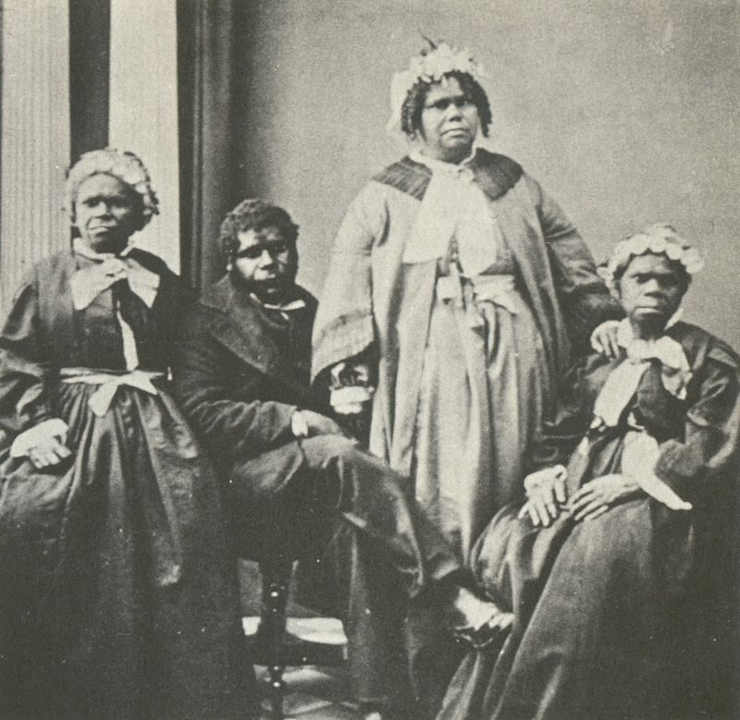

Harari, did obviously not properly research the account of Truganini, otherwise he would have chosen to write about native Tasmanians differently. But he is not to blame, because authors who write synthetic non-fiction and try to convey big picture ideas, can not confirm all building blocks they use to construct these big pictures by analytical method. So, probably there are still some vivid aborigine communities on Tasmania amongst the 17.000 who were counted in the 2006 census; but to what extent is their culture still alive? How much tradition and custom could 200 surviving native Tasmanians in 1833 hand down to their descendants? The native languages are considered to be extinct and with a language, man’s first and most important cultural identification vehicle, does usually also vanish the rest of what constitutes a culture, i.e. behavior in all dimensions of daily life. It is therefore quite plausible that the biological descendants of native Tasmanians are not only genetically, but also culturally diluted in the present Western mainstream society.

I wish somebody would proof me wrong. I would happily accept my false conclusions, because my gut feeling tells me and James Cook confirmed it, that mankind at large has thus lost a living proof of how a culture of sustained happiness could look like. Manning Clark quotes Cook’s account on aborigine in New Holland as such: They may appear to some to be the most wretched people upon the earth; but in reality they are far more happier than we Europeans; being wholly unacquainted not only with the superfluous but the necessary conveniences so much sought after in Europe, they are happy in not knowing the use of them. They live in a tranquility which is not disturbed by the inequality of condition: the earth and sea of their own accord furnishes them with all things necessary for life; […]

If even a pragmatic and for his time highly rational seafarer like Cook was intrigued by how native Australians lived compared to 18th century Europeans, how amazed would the capitalist consumer of the 21st century be? I do therefore understand why the American physician Marlo Morgan scored in the 1990ies a bestseller with Mutant Message Down Under, a book which I read 22 years ago in its German translation titled Dream Catcher. I was then about to enter university and not sure whether I should study law and psychology or medicine and was torn between John Grisham’s thriller novels and medical mystery novels like Noah Gordon’s The Shaman. I remembered Morgan’s book while researching on this chapter as part of my then reading and realized that her writing greatly formed my mental picture of aboriginal life in particular and Australia in general.

To my surprise, Morgan’s goodread reviews, are far from benevolent, labelling her as a fraud, the book bereft of any truth and its readers fools and idiots. It becomes apparent that the rational minded readers detest the book, the rather emotional readers love it, though. After skimming through quite a few reviews and reading some reports on aborigine community websites like dumbartung, I get though the impression that on both sides mistakes have been made. Back then 1995, I was probably one of those naïve readers, who believed what they read, and I would have preferred to have somewhere on in the book a clear indication that it was all fictional. Morgan made a serious mistake in not being very clear about this, but quite on the contrary giving the impression of an autobiographic account. I do also think that envy plays a major role in this confrontation between aborigine communities defending their authentic culture and an American author who probably made a killing with a fabricated story. It would have been only decent by Morgan to donate a sizeable amount of her earnings to a foundation for the preservation of aboriginal culture. Having said this, I find it quite questionable that some aborigine elders spend much time, energy and money on traveling around the globe to tell the world that Morgan is a fraud. What’s the point of this? Why not trying to use the positive energy of that book for an even so positive purpose?

What sticks with me from Morgan’s book over all those years is a message which is comparable to Erich Fromm’s To Have or to Be or the documentary Minimalism. It is a story of how modern man peels off his cultural conditioning to find his nature’s essence, a nature that was definitely lost in the individualist consuming and hoarding of 21st century capitalist societies or maybe even earlier. I wish native Australians have a similar story to tell, albeit in their own words. It would probably teach their fellow Australian citizens an important lesson.

I close this chapter with two paragraphs from another essay which I currently work on. They were written in reply to the historical documents of British missionaries describing the last few native Tasmanians cramped into religious indoctrination camps. I could not help seeing an analogy with the present self inflicted condition of “modern man”, who suffers from a mechanistic society in many ways: the increasing diagnosis of Attention Deficit Hyperactivity Disorders (ADHS) in children, the number of burnout syndromes in working people and last but not least the number of suicide cases in highly industrialized societies. Australia’s suicide data is interestingly quite comparable to the rest of the “white West”, although it enjoys a climate which is similar to Spain, Italy or Greece; i.e. countries with only half of the suicide numbers of e.g. Germany or the US.

The Tasmanians were certainly not infected with sloth, but subject to an extreme form of exogenous procrastination, inflicted upon them by a new organizational layer of an utterly different and unpardoning dominant culture. They might have been regarded by the English as retard apes, but were most likely spiritually more advanced than their new masters. What Harari describes is a clash of cultures which are socially and psychologically on a different development stage. The English did undergo serious cultural changes during the Neolithic and industrial revolution resulting in an inflated left cerebral hemisphere and a congested right hemisphere, whereas the Tasmanians still entirely relied on their intuitional intelligence which rested in their body-mind equilibrium built through a strong physical continuum during infancy and early childhood.

The epidemic suffered by the last Tasmanians repeats itself in industrialized economies. The victims are not necessarily of a different race, but are most likely subject to a more sensible biochemistry than the rest of the population and exposed to an unforgiving technocratic culture. A look at the probably most industrialized and capitalized society on this planet, the United States, reveals that suicide rates are particularly high amongst white Caucasian males. The US Center for Disease Control and Prevention published in April 2016 the report of a long term study of suicide. It states that in 2014, the age-adjusted rate for males (20.7) was more than three times that for females (5.8). The American Foundation for Suicide Prevention claims that 7 out of 10 suicides in 2014 were committed by white men. One can not help but to be reminded of the 2010 movie Company Men, which shows how the self-esteem movement paired with a capitalist system drives in particular white middle aged men into marginalization and depression.

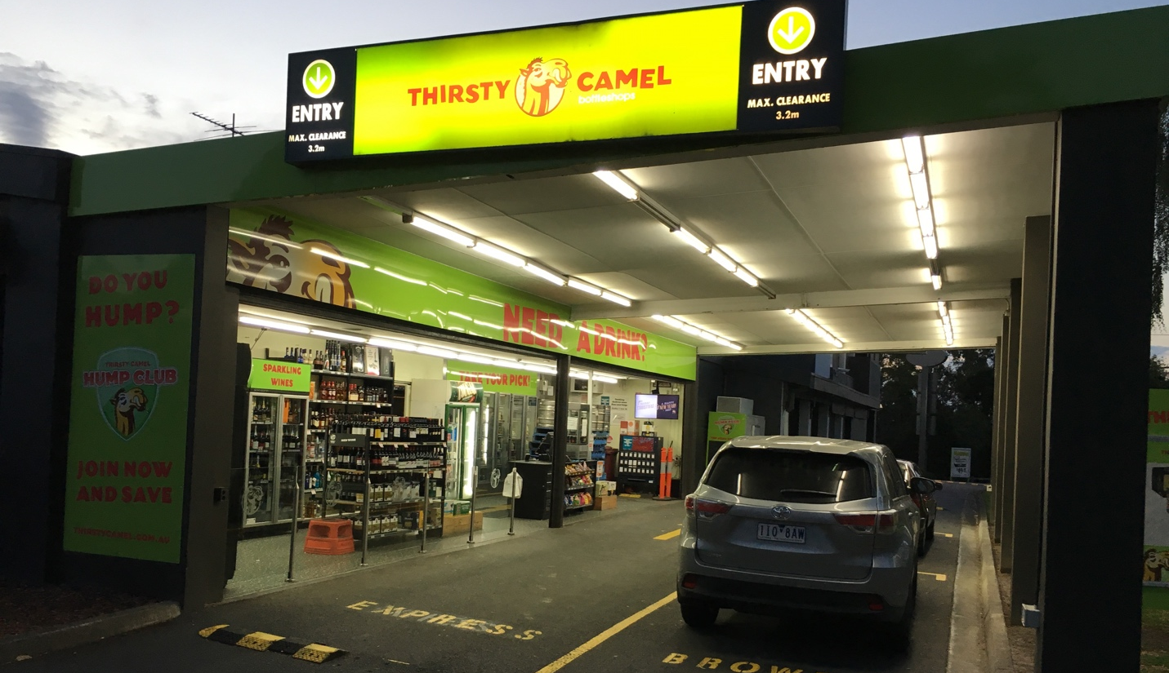
I would like to conclude this essay with a few consoling words directed in particular to my Australian friends, who have not only helped me to understand their country better, but have once and again shown that any culture can produce loving and caring individuals as well as destructive and detestable creatures. It is all in us, the good and the evil, but it is our choice to turn towards the light or towards darkness. Australia taught me that much darkness can exist under even more sun. Modern Australia was built by outstanding pioneer personalities, like James Busby, the father of Australian wine, whose life alone would be a stunning plot for an adventure movie. Australians are well advised to return to that pioneer (and convict) mentality and to remove the shackles of the law. It is a highly segregated and overregulated society, with perceived limited social mobility. Considering its current wealth and its high dependency on China, Australians will have a sour awakening, once they have to get out of their comfort zone and have to realize that their pleasure culture is one of learned helplessness.

An Australian travel writer wrote recently an article with a similar theme. He concluded that Australia has turned into a “nanny state” by comparing drinking laws and habits in Europe and Australia. Australia has something like a double moral in its system, which I recognized in different realms of daily life. In regard to alcohol it was strange to see that spirits are not for purchase in supermarkets or if then only in secluded areas, where one feels like going to the pornography section in a magazine store or a video library. The telos of such regulations must be making it harder for people to buy alcohol. Just down the road one will find though drive in stores for liquor only, like the famous Thirsty Camel chain, which counteract the lawmaker’s intention by making it super-easy for adults to get their daily dose. What citizens of advanced societies like Australia need, is more self-guidance and less regulations. The Tasman born Matthias Alexander recognized not only this back in the 19th century, but also that the body is the main vehicle to achieve self-guidance. It might be here, where we find an overlap between the lifestyle of native Australians and the ailments of modern man.

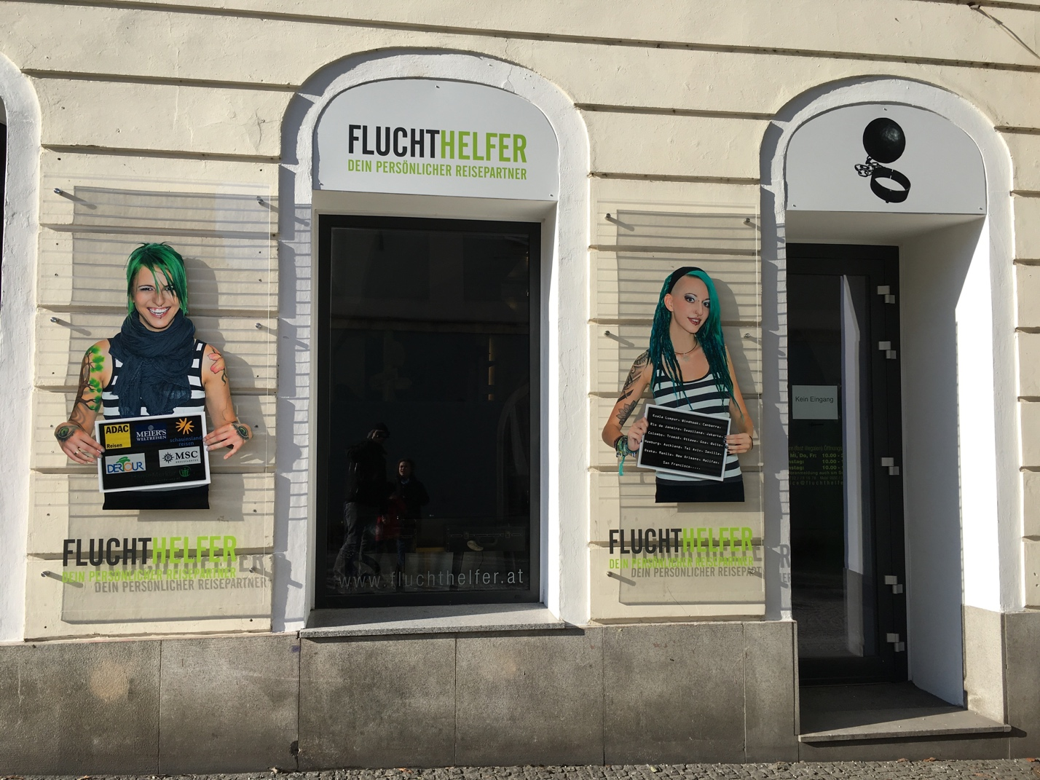

Having spent a substantial amount of time on dissecting the parts of Aussie culture, which I was able to perceive, it is only fair to turn a critical eye upon travelers like myself who visit Down Under. I have mentioned earlier that satisfaction and eventually happiness is a question of measuring one’s expectations with reality. Fly low and you can’t fall deep. There is though yet another momentum which deserves attention: our own state of mind. Where ever we go, how far that might be, we will always have a central, quite often unconscious piece of luggage with us: our own self. Although I tried to write in this essay about Australia’s culture at large and how it affects the individual, we shall not forget how our own mindset can darken the most beautiful experience. Where ever we go, we will always be with ourselves. I realized that once again, when spotting only two weeks after returning form Australia on a stroll across my native town of Linz. A newly opened travel agency called itself in large letters Escape Facilitator (Fluchthelfer). And it struck me once again, that this is the state of mind in which so many people loom nowadays; that where ever they are, they are not satisfied with themselves – I include myself – and they expect to encounter a completely different experience when traveling abroad. The further they roam, one believes, the more different the experience will be. But not much changes, because after all, we are still with ourselves; probably more than we expected, because we have more time to experience ourselves being cast out of our routines and it is this time of having to deal with ourselves, which might make a holiday no matter where it takes us, a true nightmare. I have to give Australia therefore the credit of igniting the highest expectations in Western travelers due to its remote geographical location, and naturally not being able to live up to those. Albania might fare for many such travelers much better. Alternatively try this ancient Chinese proverb as a clue for your next destination: 回头是岸 | Look inside for salvation.

KW, Shanghai, 170120 & Mühlbach am Hochkönig, 170127

